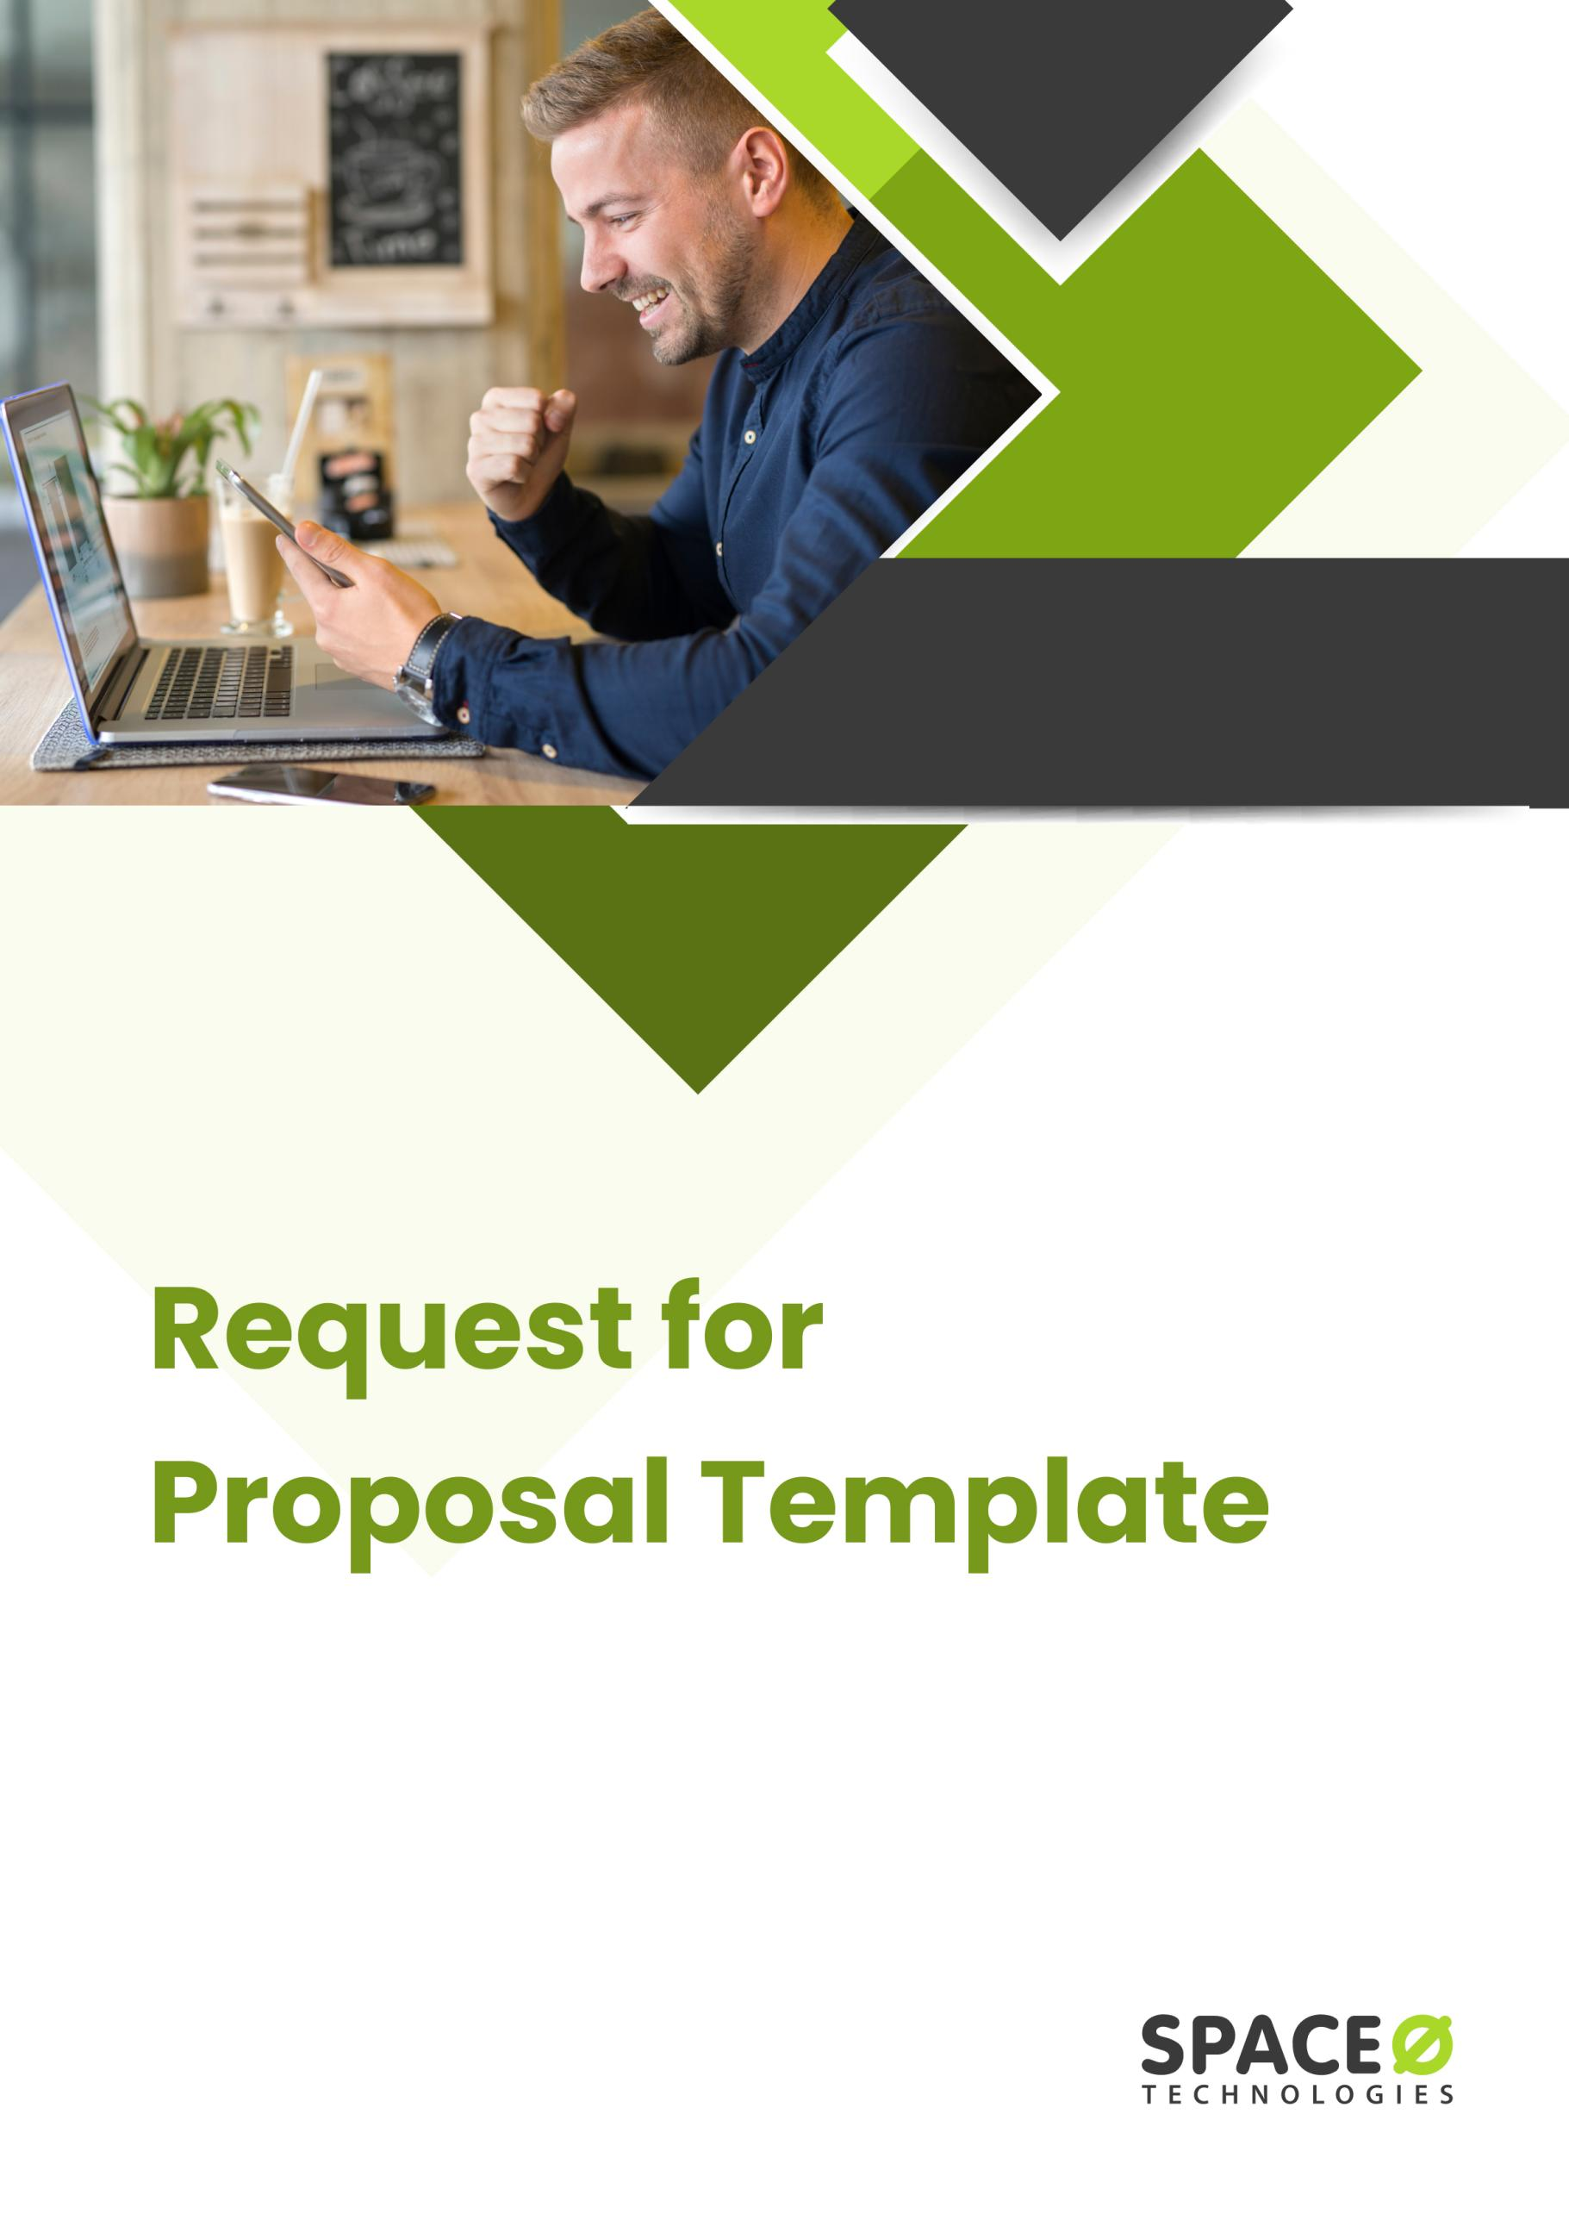

RFP

Proposal Due Date

Company Name

1. Company Overview
- Write a few words that describe the scope of your business.
- Mention the market or industry you cater to.
- What makes your product or service different from the other competitors in the industry?

Answer:

2. Business Concept and Goals
These questions will help us with your business goals and basic features.
- What is the concept of your app?
- How does it help the users?
- Who are the interest parties and stakeholders?
- What do you expect from the mobile application in the future?
- Will the solution help the customers better than your competitors?

Answer:

3. Functional Requirements of the Application
- Want to develop a new application or modify/ add new features to your existing app?
- Who is your target audience?
- What are the issues that you want to solve with your application?
- Describe a few user cases.
- Do you need third-party integration, mention those systems?
- Do you have any design templates that you would like to share with us?

Answer:

4. Non-Functional Requirements of the Application
- Which type of platform do you want to build the app on?
- Which devices should be supported?
- What are the preferred languages the app should have?
- How many users can use the app at the same time?
- Do you have any specific guidelines for the app's usability and accessibility?
- Attach your company’s brand images and other designs if any.

Answer:

5. Preferences or Restrictions of the Project
- Are there any technical preferences?
- Are there any legal requirements such as HIPAA, CCPA, or any other that we need to comply with?
- What is your total budget for the app development?
- What is the timeline or timeframe?

Answer:

6. Budget
- What are the platforms you want to build the application?
- What are the functions and features of the application?
- How many user flows do you need for the application?
- What quality and experience are you looking for a mobile app development agency?

Answer:

7. Project Timeline
- Which date do you want the project to launch?
- Are there any dependencies that may affect the launch date?
- When do you need the development to start?
- Do you have any expectations about how long the project will take?

Answer:

8. Proposal Timeline
- Provide the due date for proposals to be submitted.
- Provide the timeline for evaluation of proposals, presentations, and selection of winning development company

Answer:

